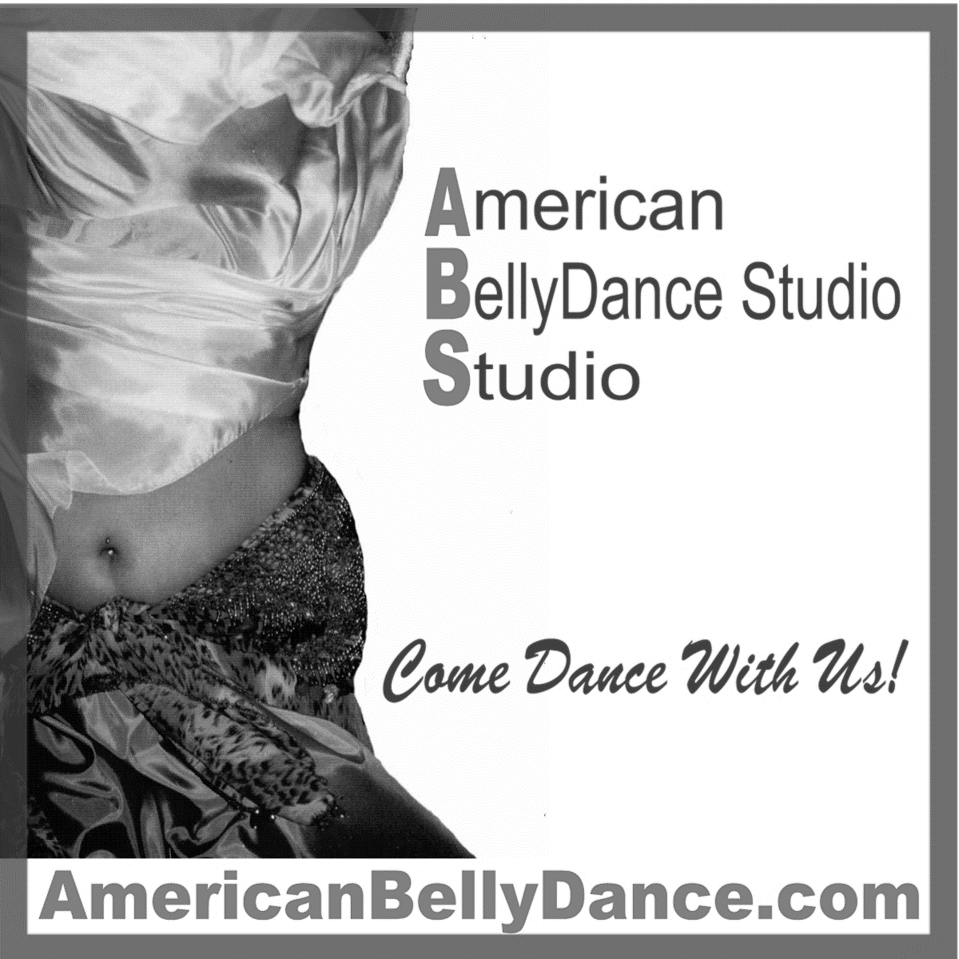

Student Handbook- Performance Guide

Fourteenth Edition
2019

Welcome to the American BellyDance Studio. We are so pleased you have decided to join us for dance and fun!

We have prepared this handbook to introduce you to our dance family. It contains general information you will use as a dance student and answer many commonly asked questions. Please use this handbook in combination with your dance instructor and/or Kadayif/Kandy (Studio Owner/Artistic Director) who will guide you through your program of study at ABS.

Updated information will be given to you periodically. Please note that the handbook is also located online (www.AmericanBellyDance.com-ABS Dancer Info).
There is wealth of information on our Web site accessible only to our students. Click on ABS Dancers Info tab and put in this password BellyDance (caps are required) and you will have access to information like this student handbook, basic Isolation list, Costuming information, and information about upcoming events that is not accessible to the general public.
We would welcome any input regarding this publication and how we might improve it to better serve your needs. We believe this year holds new and exciting opportunities for you in dance and friendships made.

Sincerely,

Kadayif/Kandy
Kadayif/Kandy Sinquefield
Owner/Artist Director
American BellyDance Studio

Mission Statement and Motto and Goals

Mission Statement: To provide quality Belly Dance instruction while building self-esteem and self-confidence through friendship and presentation of learned knowledge.
Motto:
“If it’s not fun – we don’t do it!” “No Divas – just shining stars”

The American BellyDance Studio believes that all dancers are beautiful regardless of age, sex, size and physical limitations.

Goals:
The goals of our dance studio are to provide sound dance techniques, improve mobility, muscle strength, improve self-confidence and encourage personal growth of students, all while having fun.

American BellyDance Studio
The Sydney Center
102 Whitaker Road, Lutz, FL 33549
813-416-8333
E-mail: AmericanBellyDanceStudio@gmail.com
www.AmericanBellyDance.com

If students have any questions regarding any event or this booklet, please see Kadayif.
Getting Started
The American BellyDance Studio is delighted that you have chosen to dance with us. Our dance studio offers an exciting opportunity to train and expand your knowledge of dance. Whether you are taking classes to perform or strictly for personal edification, we are pleased to help you in your desire to learn and perform BellyDance.

In addition to our basic level instruction, advanced students my study different styles of bellydance and how to use props in their dance.

General Information
Class Attire
Proper attire is required for classes. This includes workout/exercise clothes, yoga pants, leotards and/or tights or other clothing that allow students to move freely— no blue jeans and no loose shirts—the instructor needs to see your body move.

Hard sole shoes, chewing gum, and cigarettes are strictly forbidden on the studio floor.

(DiscountDance.com-use code 51013 for discount and shipping discounts)

Shoes and other dance class wear can be purchased at Discount Dance.com. Search for our studio dress code to see approved items—like shoes.

Footwear
Dancers are bare footed when dancing, so no shoes are required for class.
No socks please—they increase the chance of you slipping while you move.

Dancers may wear the following shoes in class and at outside performances:
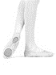
Split sole ballet shoes (see attached photo).
You can purchase these shoes at most Dance Stores or you can order them online at:
Discount Dance Supply

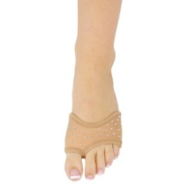
Dancers may also wear:
Dance Paws
These come in a variety of styles, colors and enhancements…these are particularly good for dancers who spin quite a lot on the balls of their feet and need the added cushion. They are available online or in our Emporium. (do not wear these for outside performances as the heal has no protection)

All other dance shoes must be approved by instructor.
Absolutely NO HARD SOLE shoes on the dance floor.

Hip Sashes/Scarves are not required, but most dancers feel they help them feel the movement. Hip Scarves are available for purchase at the studio in a variety of styles, colors and prices.

Costumes for Performances: Students are required to provide their own costumes for performances. Sewing classes will be offered before major performances to assist students.
If you have questions, see your instructor. Also see the ABS Performance Guide for more information on performances and costuming

Studio Floor
The studio floor is constructed of suspended wood in order to decrease the stress on dancers’ joints. In order to keep the floor clean and free from marks, blemishes and particles that could damage its surface please place all shoes in the appropriate racks located in each classroom. Please do not wear shoes on the stage.

Policies and Releases

All students must read and sign the following policies prior to taking classes at ABS. Students under 18 must have the signature of their legal guardian prior to participating in class. This information is located on the registration form (online and printed)
Photo/Video Release
The undersigned gives permission to the American BellyDance Studio, its owners, instructors and operators to video and/or photograph any participants in ABS activities and use these media to promote the studio and or BellyDance without monetary reimbursement of any kind.5

Release of Liability
As the registrar (or legal parent or guardian if registrar under 18), I release and hold harmless the American BellyDance Studio/The Sydney Center, its owners and instructors from any and all liability, claims, demands, and causes of action whatsoever, arising out of or related to any loss, damage, or injury, including death, that may be sustained by the participant and/or the undersigned, while in or upon the premises or any premises under the control and supervision of the American BellyDance Studio/The Sydney Center, its owners and operators or in route to or from any of said premises.
Medical Emergency
The undersigned gives permission to the American BellyDance Studio/The Sydney Center, its owners and instructors to seek medical treatment for the participant in the event they are not able to reach an emergency contact or parent or guardian (if user 18). I hereby declare any physical/mental problems, restrictions, or condition and/or declare the participant to be in good physical and mental health.
I've read the above and agree.

Class Registration:
Enrolling and dis-enrolling in a class is the responsibility of the student. Students may do this via the website portal or thru their teacher or by emailing AmericanBellyDanceStudio@gmail.com.
Automatic tuition charges will be posted to the students account at the first of the month unless the proper dis-enrollment procedures are followed. If this occurs, please see Kadayif to update your account.

Auto pay is recommended for students. This allows the studio to charge your credit/debit card monthly for your tuition. Your tuition will be charged on the 1st of the month (or closest business day). You may cancel auto pay at any time.
Here is how to sign up:
Go to AmericanBellyDance.com> click on Classes tab>Click on Enroll in Classes > Sign in using your email address and password [First time to sign in--click create account and complete the information (be sure you use the same email address you used on your registration). Once you are signed in, pick Enroll in Auto Pay> click sign up and then provide your Credit/Debit info. {this is always secure thru the system}]. If you need help just ask Kandy/Kadayif before or after your class.

Class Structure
Class size is limited to 8 dancers.
A class must have 4 scheduled participants in order for it to be held.

Level I Classes will be offered at a variety of times and days.
This is a beginner class focusing on basic isolations/rhythms/combinations. (see isolation list)
Students may remain in this class until they feel comfortable with basic isolations.
Level II classes will be available as a next step after the Level I Class. This class will focus on a continuation of the basic Level I class with more emphasis on performance and more complex combinations and choreographies. Times and days will vary depending on need. (see website for list)
Level III classes will incorporate the addition of advanced isolations, combinations and choreography and will be offered at a variety of times dictated by student needs. (see website for list)
Troupe Classes will be conducted with participation by invitation only. If you are interested in being in a troupe, talk with your instructor.
Every effort is made to place students of like experience and expertise in the same class; however, this is not always possible due to class size restrictions. Please let your instructor know if you are overwhelmed or if you are not being challenged in your classes so proper adjustments can be made.

Tuition
Tuition is due the first class of the month.
Students may pay by cash, check or credit card, and may also pay online.
Auto is a great way to prevent late charges because you forgot to pay your tuition.
Automatic payments can also be set up on the web site. (see above for details)

Please make all tuition checks to Kandy Sinquefield

Established students will receive their account balance the first of every month. (via email)
Please note payments made in the studio may not show up on your account for about a week.
If your tuition is not paid by the 15th of the month it will be subject to a $10.00 late fee.
If not paid by end of month you will not be able to attend class until your account is up to date.
Current Tuition is as follows:
Monthly Class Discount - $58.00 per month
(no credit for classes missed, but makeup classes may be scheduled--see your instructor)

Single class payment -$ 18.00 per single class – no discount

Monthly Unlimited Class Card: We do not offer unlimited class cards as our classes are structured so students are grouped per experience level. Using this method students are not bored or overwhelmed with class material. The Unlimited Class Card format makes it impossible to offer individual, quality classes for all levels of students, however, we do offer discounts for multiple classes (see below)
Class Discounts: (this only applies if you are paying by the month)
Students or families taking more than one class per week receive the following monthly discounts:

First class: $58.00
Two classes: $110.00 (10% discount on 2nd class)
Three classes: $ 159.00 (15% discount on 3rd class)
Four classes: $205.00 (20% discount on 4th class)
Five Classes: $ 248.00 (25% discount on 5th class)
Six classes: $2288.00 (30% discount on 6th class)

Examples:
Mary (mother) and Sue (daughter) both take one class per month. The total fee for this family is $110.00.
Jane takes a total of three classes per month - her tuition fee is $159.00

Students entering classes mid-month will pay per class till the end of the month, then they are eligible to pay on a monthly basis and received the monthly discount.

All specialty seminars and workshops will be priced on an individual basis. See individual class information for details.

Check Return Fee:
All checks that are returned will need to be redeemed for their face value plus $25.00 returned check fee (The bank charges the studio this amount when a check is returned). In the event that more than two checks are returned in a 6-month period, cash/credit card payment will be required on a go forward basis.

Attendance
Classes will start on time. If you must join the class late, please be sure to enter quietly and do not disrupt the class already in session.

Students are encouraged to arrive shortly before class, and wait in the Ready Room, or kitchen area until their class begins.

Class will start on the hour and end five minutes till the hour (example: 6:00pm – 6:55pm). This will allow the departing students time to ask any questions, exit the studio and the arriving students time to assemble so the next class will start on time.

Please notify the studio (813-416-8333) or your instructor if you will not be in class.

Cancelled Classes and Weather Policy
From time to time it may become necessary to cancel classes or provide a substitute teacher. Whenever possible the classes will continue as planned and there will be a substitute teacher assigned to conduct the class. In the unlikely event that a class must be cancelled, students will be notified as soon as possible by phone and e-mail.
It is very important to keep your Student profile up to date with current phone numbers and e-mail addresses. Please update your information online or with your teacher.

Inclement Weather Studio Policy:
Please check your e-mail/voice mail before coming to class in the event of bad weather.
If Hillsborough County is under any type of weather warning or watch from 3 till 10pm on the day of your class (tornado, hurricane, tropical storm etc), a decision on whether to hold class or cancel will be made by 3pm. The decision will be communicated to all student via email and text message after 3pm.

If you feel the weather is too dangerous for your travel, even if we are not under a warning or watch, please call/text the studio and notify us that you are not coming (so we don't worry) and stay safe.
Studio phone: 813-416-8333

Illness Clause
Because we are in close contact while taking class, we ask that if you are sick (contagious illness such as flu, cold etc.) please do not attend class. This is one time when sharing is not a good thing.

Lost and Found
Items left at the studio will be placed in the Lost and Found box for a period of one month (located in the kitchen area). If not claimed, they will be discarded or donated to charity.

Communication
Communication is necessary in order to maintain a smooth-running studio and/or performance. Students will be kept up to date in the following manner:
Monthly Student Newsletter: Once monthly students will receive an email informing them of events, happenings and requirements for the month. It will be email and will also be available on the website.
Handouts – Occasionally handouts will be provided to students for special events. These handouts will be provided on a limited basis, so it is advisable to put your name on your copy and keep it. Additional copies may not always be available. If you are not in class at the time of distribution, a copy will be reserved for you.
White Board – Upcoming events will be posted on the white board in the hall, check here before class for the latest information on events and performances.
Additional Bulletin Boards will display articles of interest, upcoming seminar brochures, sign up sheets and other items of general interest.

Studio Web Site
The Official Web Site www.AmericanBellyDance.com has a section specifically for students (ABS Dancers Info). It requires a passcode to gain access. The passcode is BellyDancer This section contains the Student Handbook and information for students regarding upcoming events/performances and other items of interest. Please do not share this passcode with anyone outside of the studio.
Holidays and Studio Closings
The studio will be closed
New Years Eve and day
July 4^{th --}No classes > picnic
Labor Day
Halloween
Thanksgiving Day, the Wednesday before
Christmas Eve and day
The Week between Christmas and New Year
Any other closings will be announced by the instructors.
Sydney’s Magical BellyDance Emporium
(our inhouse boutique)

The Emporium offers bellydance merchandise including but not limited to hip scarves, costumes, jewelry, hair adornments, as well as stage makeup, essential oils, salt lamps, shimmy shimmer and more.
All items must be paid for in full before being removed from the studio.
When purchasing items, please place the attached tag and your payment in an envelope and place in the tuition box. See your teacher or Kadayif for assistance.
Special order items must be paid for prior to being ordered. (i.e. veils, swords, individual costumes and materials for costumes)
Studio Events (this is a partial listing)
Throughout the year students have the opportunity to participate in a variety of events sponsored by ABS. Participation is voluntary but always a lot of fun!

Studio Gatherings – a quarterly “bring a dish to share” meeting with informal dancing and fun!

STARS Annual Awards Banquet- STARS is our annual Awards Banquet. Student dress in semi-formal/formal attire. Customary cost is ranges from $25-$35 per person depending on the catered menu. Family members may attend also (no children other than enrolled students please). This event is themed after the OSCARS and is inclusive of a red carpet walk with paparazzi, interviews and many other surprises.

BellyDance Showcases (Gala, Spooktacular, Jingle Hips) – The Studio features their students in three showcases throughout the year. Students perform in groups, troupes and solos. A performance fee of $20.00 is required from each student to cover performance and production expenses. Students are responsible for obtaining/sewing their own costumes. Also see the ABS Performance Guide for more information on performances and costuming;
Showcases are held in our performance theater.

Lutz 4th of July Parade - students participate in the parade, throw beads and staff a booth on the parade grounds to help promote the studio. The Summer Gathering is held the same day and students meet afterwards for a catered lunch (Hungry Harries Barbeque). The cost is around $15.00 per person.

Ms American Belly Dance Pageant – A chance for anyone to be a beauty queen. Contestants are judged in evening gown, interview and on their talent—BellyDance. All levels of dancers may enter.
Other Performances and Outings are scheduled throughout the year and announced to the students when details are available. Check the website for more details – AmericanBellyDance.com

Studio Fund Raisers
Help the studio by “clicking thru”.
On the website you will find the above amazon logo in the upper right-hand corner. If you are an amazon shopper---go to our website (AmericanBellyDance.com) and click on the Amazon icon before you shop.
By clicking on the icon you tell Amazon that you are coming from our website and they will send us a referral fee (its not much, but every little bit helps).
You must do this each time you want to shop on Amazon (for us to get the fee)…but it keeps tuition low and tickets prices reasonable. So please click thru and don’t forget to tell your friends! Anyone can support the studio by clicking thru! Pick up cards to hand out to your friends…and share the support.

You can also support the studio by purchasing from the following vendors:
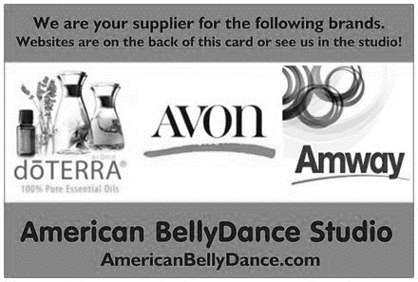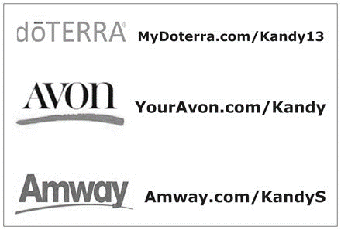

Magazine Fund Raiser
Like Magazines and subscribe to them regularly---order them here and help the studio.
https://mystore.fundraising.com/Store/Category/933?t=6b70f6d2-cde3-41be-b0a6-f0db668fbc1c
(this link is also on the website under Fund Raisers.). Or go to Fundraisers on the Web site

The Studio uses many methods of raising money to keep the studio/theater running.
Please shop at these vendors…all proceeds go to help the studio stay affordable.

Student Performance Handbook

Performance Locations
The Sydney Center
The majority of our performances will occur in the SCM (Sinquefield, Cote’, Moss) Performing Arts Theater in the Sydney Center at 102 Whitaker Road, Lutz, FL 33549.
This facility will seat 60 guests and has a suspended wood floor (for joint safety) and professional lights/sound.
Other Locations
Occasionally performances will be held at facilities outside The Sydney Center. Your instructor will give you information regarding these locations.
It is recommended that students purchase shoes for dancing at outside venues. See student handbook for examples of acceptable shoes to wear during performances.

Participation in Performance Events
Students are encouraged to participate in our shows and events. Participation is not required. If you are not interested in performing in a specific event, please notify your instructor as soon as possible. Students may remain in class and learn choreography but not perform or they may transfer to a non-performing class. (Cardio BellyDance etc.).
New dancers who are not seasoned enough to participate on stage (dancing with studio less than 3 months at Show date) can still be part of the fun. We need you to assist with other tasks. Please volunteer your services if you can. Let Kadayif or your instructor know if you would like to volunteer.
Costumes
Each choreography requires specific costuming, which is outlined on the line-up sheet or by your instructor. The dancers are responsible for obtaining all costuming including any props necessary (unless otherwise noted).
The studio does not rent costumes for performances. Instructors will discuss costuming needs with each performing class and arrange sewing classes or coordinate group purchases from outside vendors.
Cover-ups are required for all dancers who wish to leave the dressing room area in costume. No costumes are to be worn without cover-ups in the audience areas, except at the end of the show when dancers greet audience members. NO EXCEPTIONS

Sewing:
Sewing classes will be coordinated by instructors for those classes who will be making their own costumes.
Instructors will coordinate group purchases of materials and accessories needed to construct costumes. Material must be paid for in advance or order. If you miss the order date you will not be able to perform as you will not have the appropriate costuming material. (See your instructor if this might apply to you)

A date for cutting out patterns will be scheduled. (Studio patterns must remain at the studio and cannot be checked out)
If students are interested in sewing their own costumes, instructions will be provided. If not, students may have their costumes sewed by other studio members for a minimal fee…see price list below)

Basic Sewing Prices
This is for sewing ONLY and does not include material cost (including elastic needed for waistband, wrists or costuming class charges). All sewing projects must be cut out prior to sending to seamstress.

Basic Beledi dress - $25.00
Beledi dress w/Gawazee neckline or sleeves - $30.00
4 Panel circle skirt - $35.00
Less than 4 panels - $30.00
Sarong/straight/panel skirt - $30.00
Harem pants - $25.00
Sleeves - $15.00
Tie top - $25.00
Fitted top - $35.00
Roll hem a veil - $10.00 (you provided, we hem)
Roll hem a skirt - $15.00 (you make, we hem)
Gauntlets, gloves, brace covers etc. - $10-$20
Coverups - $10.00
Other projects – discuss with instructor or seamstress

Ordering Costumes
If costumes are to be ordered, your instructor will discuss in your class, provide prices and color choices. Measurements will be taken and costumes will be ordered at the same time (to receive maximum discounts for students). All costumes must be paid for by the order deadline. If not, you will not be able to dance as you will not have the appropriate costume.
Emporium purchases
Costumes, costume props and jewelry, as well as other items, may be purchased in Sydney’s Magical BellyDance Emporium inside The Sydney Center.

No Merchandise may be removed from the Emporium without payment.
Items in the Emporium are for sale and not for use by students and therefore cannot be borrowed.

Performance fee
All student who perform in any ABS ticketed performance must pay a performance fee and commit to the performance.

This fee helps cover costs for production of the event including printing, handouts, music CD/flash drives, promoting, extra classes for practice/rehearsals and costuming classes.

The Performance fee is $20.00 per person, $30.00 per family (more than one dancer) and must be paid no later than 1 month before the performance.

Performance fees for non-ticketed performances such as Hafla’s, studio parties etc are usually a covered dish to share—see individual event information sheet for specifics.

General Rules

Back Stage Area: Dressing rooms will be set up in the classrooms with racks and tables/chairs, you will be assigned to the appropriate classroom prior to the performance.

Please remember to keep noise volume low in these areas, because the audience CAN hear you.

The door between stage and dressing room should remain closed unless dancers are entering/exiting.
The door from Classroom 2 to the hall will remain locked during performances for privacy, dancers will enter thru the hall into Classroom 1. (please be aware that dancers may be changing as you enter)

No One, will be allowed back stage except dancers and staff. Please tell your family and friends.

In addition, no colored liquids or food will be allowed backstage or in the dressing room.
(Red wine looks really bad when spilled on a white skirt!!!).
Water will be provided for the dancers (located in blue container in classroom 2)
There will be a designated eating area where you can escape and eat if necessary (in the area behind Kandy/Kadayif’s desk that is curtained off)

NO ALCOHOLIC BEVERAGES OR RECREATIONAL DRUGS BEFORE OR DURING THE PERFORMANCE.

On shows that have two performances in one day, dancers are encouraged to bring a “finger food” for our break between shows. See individual Performance sheets for details.

Dress Rehearsals All ABS student performances will have dress rehearsals scheduled the Friday before the performance at 7pm. Students are required to attend this dress rehearsal. If you absolutely cannot attend, please talk with Kadayif/Kandy as soon as you know you will not be able to attend. This rehearsal is where we finalize the lineup and block the numbers performing. It also gives dancers a chance to perform on the stage as practice. (updated 5/15/18)

Extra Classes
Additional classes will be scheduled as needed by the instructors for additional practice and/or costuming on a by class basis. There is no charge for these additional classes. (your performance fee helps cover this)
Soloists who wish to book practice time at the studio, please get with Kadayif.
Group rehearsals (for opening and closing numbers) will be held at the end of one class and beginning of the next class as we get close to the performance if applicable. Kadayif will also visit each class to demonstrate the format of the dance as needed.

Rehearsal time for specialty numbers-duets/trio—outside of regular class performances—will be scheduled with those participating in the performance number.

Class Attendance: Dancers must attend class regularly and be responsible for learning choreography and obtaining their costumes if they wish to perform in the show.
If you miss more than 6 regular classes (Starting 3 months before the show), you will not be prepared to dance and may be asked to sit out. (updated 5/15/18)

If you do not know the choreography or have your costume ready by your regular class time two weeks before the performance, you may be asked to withdraw from the choreography.
Our main goal is to have a positive experience for all dancers. If a performance will be compromised by a dancer that does not know/can’t technically perform the choreography, she will be asked to withdraw from that choreography as a courtesy to her fellow dance sisters/group members.
Dancers who feel they fall into this category—please talk with Kadayif or their instructor.

Ticket Sales
Students are encouraged to sell tickets in advance of the performance. This helps us plan seating and prepare programs.

Tickets will be available for purchase on line at the website or in the studio after class. The shows usually sell out so if you need tickets for your family and friends, please purchase them early.

Ticket price: $15.00 per seat in advance (up to 2 weeks before show)
$20.00 per seat 2wks in advance and at door if applicable

Photo Shoot:
Once a year a general photo shoot will be offered to the students where they may have their photos taken in 3 costumes of their choice. CD’s of these photos will be made available to the students for $25.00 per person. New students may borrow costumes from Kadayif or their instructor if needed. The shoot will be held the week following a major performance (GALA). All students are encouraged to attend as these photos are not only useful to the student but help promote the studio as well. (updated 5/15/18)

Program: A program listing the performers and studio information will be provided to the audience at the door.
A keepsake program will be issued to the students the week after the performance.

Dancers are required to provide their dance name (if not done previously) to Kadayif at least 1 month prior to the performance. Please text or email your name. If you need assistance selecting a name, see Kadayif, your instructor or the “name book” in the studio.

Flowers: Family and audience members that wish to present flowers to dancers can do so after the performance.

There will be flowers for sale to the public, students or teachers on the day of the show. A special note can be attached to flowers to personalize the gift. Prices range from $2.00 – $10.00 and all proceeds go to help pay the cost of construction for our theater. These flowers are “wooden” and make a wonderful arrangement that stays beautiful.

Cast Party after Performance
A cast party will be arranged to immediately follow the last performance. The usual location is the Village Inn on Hwy 54 If you plan on attending, please sign up prior to the performance.

Individual Event Sheets
For each event an event sheet will be given to those students wishing to perform in the event. This sheet will contain deadlines, and additional information regarding the performance.

